Project 3 Report
For: Federal Highway Administration (FHWA)
Author: Blake Green

Table of Contents

Table of Contents 2
Table of Figures 2
Introduction 3
Methods 4
Results and Discussion 6
References 12

Table of Figures
Figure 1 - Bar Chart Made in Python 6
Figure 2 - Histogram Created in Python 7
Figure 3 - Boxplots Created in Python 8
Figure 4 - Time Series Plot for Acceleration Made in Python 9
Figure 5 - Position Time Series Plot Made in Python 10
Figure 6 - IDM Simulated Follower Comparison with the Leader and Actual Follower 11

Introduction
This project was created for the Federal Highway Administration (FHWA), which asked us to analyze travel behavior and vehicle dynamics to better understand mobility patterns, characteristics of vehicles, and traffic behavior. The goal was to provide clear, reproducible visualizations and create a simulation using the Intelligent Driver Model (IDM) so that the data can be used to inform transportation planning and decision-making regarding transportation related problems.
To accomplish this the FHWA gave use two datasets. The National Household Travel Survey (NHTS) gives detailed information on household travel, vehicle ownership, and other demographic data. The Next Generation Simulation (NGSIM) dataset contains second by second vehicle trajectory data, which offers real time measured statistics such as speed, acceleration, and position of a car over a time period.
The project workflow involved transforming the raw data into organized Python scripts. These generated histograms, bar charts, boxplots, and time series plots that were relevant to the Federal Highway Administration. The IDM simulation was then implemented to analyze car following behavior under different trajectories and conditions. The methods for these are documented in this report and are reproducible for further analysis.

Methods
The methods for this project involved transforming the raw datasets, NHTS and NGSIM, into clear and reproducible visualizations/charts using Python. The goal was to follow the client’s request for charts that highlight important patterns regarding transportation and driver behavior. The work for this project required us to follow clear organized steps starting with cleaning the data, then moving to creating the plots, and ending with the Intelligent Driver Model (IDM) simulation.
The First step was to identify which variables would be used during the project and for which plots they would be used for. For the NHTS data set, household vehicle count will be used to make the bar chart showing how many vehicles households typically own. Household size and the counts of that variable were used to create a histogram. Vehicle age was made into boxplots by car types. Using vehicle position from the NGSIM data set a time series plot was created to show how a vehicle’s position changes over the course of the time period. Then another time series plot was created using the acceleration of a car to show fluctuations in the acceleration over the observation period.
The second step was to insert the NHTS and NGSIM csv files into the .ipynb Python code file. Then pandas, along with seaborn and matplotlib were imported so that we could complete statistical analysis and create plots. We also needed to clean the data in this step such as taking out missing values from certain columns and making sure everything was ordered correctly.
The next step was to start constructing the plots in Python. Each plot required a separate block of individual code. For the bar chart the household vehicle count column was summarized using a value count and the data from those counts were plotted using matplotlib and the bar() function. The histogram was made by taking the travel time values and plotting them with the hist() function using an appropriate number of bins. The boxplots were created using the trip distance values grouped by transportation mode and then plotted with seaborn. Each plot created includes axis labels, a title, and appropriately placed/sized legends.
The fourth step is to construct the time series plots using NGSIM data. This required using a single vehicle’s trajectory by filtering the data for a specific vehicle ID. Then using matplotlib a time series plot was created for the position against the time the vehicle was observed. The same process was applied for the acceleration time series plot however the acceleration data was used instead of the position data.
The fifth step is to demonstrate the Intelligent Driver Model (IDM) simulation. The IDM equations were translated into Python functions. The parameters like speed, minimum spacing, and acceleration rates are defined at the beginning of the simulation. The model then runs over a series of times and updates the statistics. The output trajectory was then plotted so that the client could visualize the results.

Results and Discussion
The first chart created was a bar chart in Figure 1 that showed the distribution of vehicles per household. This graph shows that most households have between one and three vehicles, with a steep drop as the number of vehicles increases. Understanding vehicle ownership is important for the FHWA so that they can make educated decisions about travel demand and roadway usage. Therefore, knowing the number of vehicles per household can be important because a high number of vehicles could mean more road usage, thus more traffic and vice versa. These insights can support planning for infrastructure and future policies related to FHWA’s work.
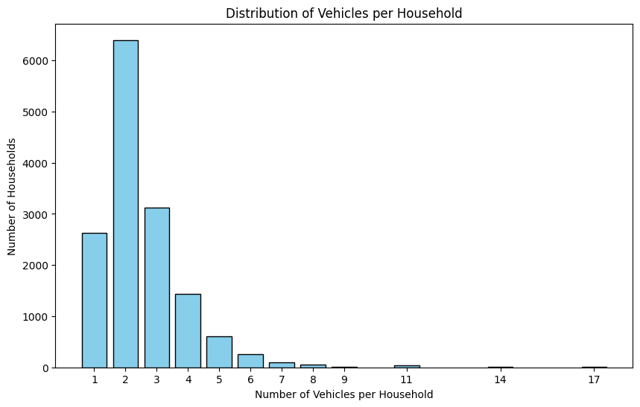
Figure 1 - Bar Chart Made in Python
The histogram shown in Figure 2 depicts a distribution of household sizes. This graph shows that most households contain between one and three people with a steadily decreasing pattern as the number of people in a household increases. This pattern mirrors that of the bar chart that was described previously. The similarity between the two distributions helps validate the travel behavior inferences that were made from the previous graph. This distribution ends up being very useful for transportation planners because household size is an important input for estimating trips, road demands, and public transportation needs. A population with relatively smaller household sizes may have more moderate travel volumes which lowers the need for road capacity and parking needs. As more surveys are taken and trends are identified that the average household size is increasing then a transportation planner may need to adjust for increased traffic volumes and influxes of vehicles. When this happens, cities end up needing to expand roads and start construction projects based off these inferences.
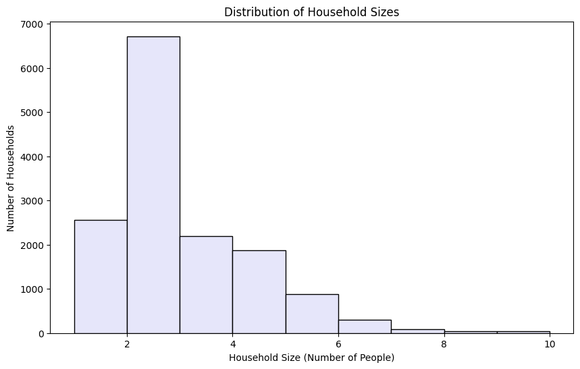
Figure 2 - Histogram Created in Python
The boxplots comparing vehicle ages across different vehicle types are shown in Figure 3. Most brands had a concentration of vehicles in the 8–15-year-old range which indicates that a large portion of the cars remain exceptionally functional past the early stages of ownership. Multiple makes displayed a significant number of old outliers which suggests that these suppliers, such as Ford or GMC, can remain on the road for extended periods. Although many of the brands are very similar, the ones that do vary can show differences in durability, ownership patterns, and cycles of ownership (replacement) throughout the market. This is relevant to the industry because it is important to understand how vehicle age varies so that we can plan for older vehicles that may need roadside assistance and have extra shoulder space if a population’s distribution is much older. Additionally, these vehicles may not be fuel efficient so in rural areas there may need to be planning for services in specific areas. Transportation planners can also use this graph to recognize trends related to fleet turnover and adjust when new cars are being introduced.
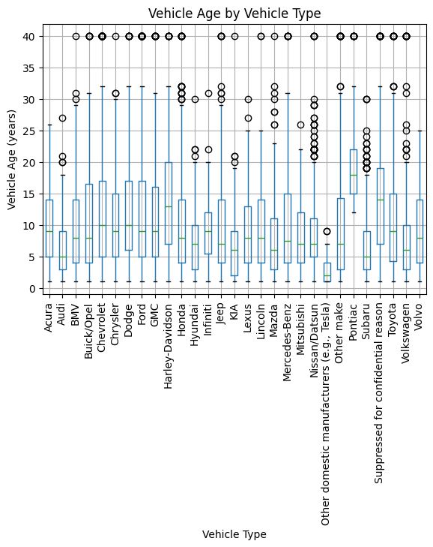
Figure 3 - Boxplots Created in Python

The next plot created for FHWA was the acceleration time series plot in Figure 4. The plot shows that not all driving behavior is uniform. The vehicle has frequent shifts between acceleration and deceleration with spikes that indicate hard braking or strong acceleration respective to a negative or positive slope. These patterns can suggest that there are dense traffic conditions or that the driver is responding to external factors like merging vehicles, lane changing, or even weather. This data is important for evaluating the dynamics of a vehicle. Variations in acceleration, especially in short periods of time, can show inefficient traffic systems that may need to be reevaluated and have more efficient systems put in place.
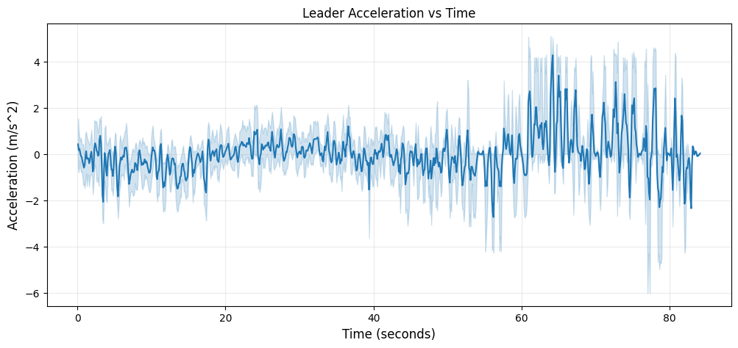
Figure 4 - Time Series Plot for Acceleration Made in Python
The position time series plot that was made is in Figure 5. This graph shows the trajectories of vehicles over time. It has periods of linear motion as well as stopped progress. The data shows how vehicles cover distance over time with different traffic conditions. Analyzing the position gives direct insight into traffic dynamics and roadway efficiency. If there is a plateau in movement it can show congestion and interruptions that can slow travel speed. Steep slopes can show moments of low traffic and free flowing conditions paired with higher speeds. This is valuable for traffic engineers for calibrating simulation models like the Intelligent Driver Model (IDM) simulation used for this project. Understanding certain position changes like abrupt stops or fast lane switches can be important for designing safe roadways that avoid contributing to unsafe driving habits.
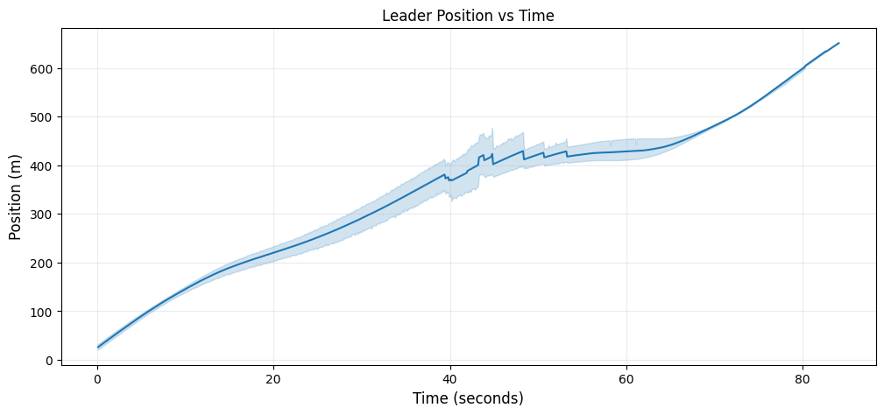
Figure 5 - Position Time Series Plot Made in Python
Figure 6 shows another position vs time graph. This plot has a leader vehicle, an actual follower vehicle, and a simulated follower vehicle generated by the Intelligent Driver Model (IDM). The simulated follower nearly mirrors the real follower’s trajectory. There are a few minor deviations that occur seen between 20 and 30 seconds where the simulated follower would be ahead of the actual follower. Simulations like this are very important for understanding traffic dynamics without impacting real time traffic. By comparing the simulation to a real follower, transportation engineers can estimate with good accuracy data like vehicle response times, following distances, and other behaviors. The close alignment between the simulation and the actual follower demonstrates the accuracy of the model and that it can be reliable for drawing conclusions about driving behavior. This can be further tested by trying out different trajectories for further analysis in the Python code file. The simulation also allows us to change variables like following distance, response time, and starting velocities so that we can analyze follower behavior with great accuracy. More scenarios that can be tested are increased traffic density and weather conditions so that transportation engineers can plan accordingly for all traffic events.
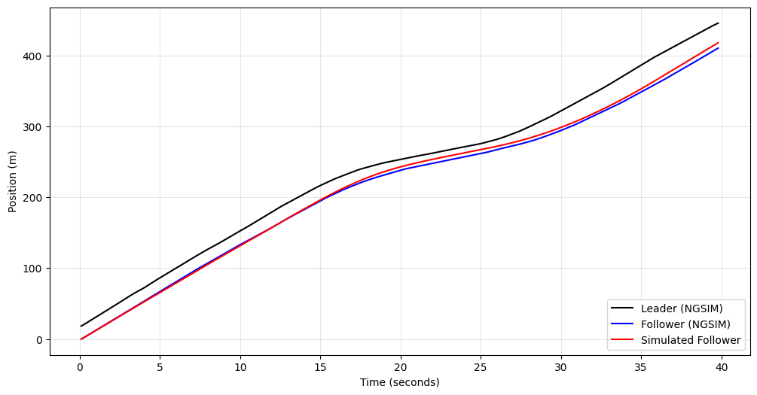
Figure 6 - IDM Simulated Follower Comparison with the Leader and Actual Follower

References
NGSIM(in).csv. (2026). Vehicle trajectory and speed data [CSV file]. Internal dataset.
NHTS(in).csv. (2026). Household travel survey data [CSV file]. Internal dataset.

